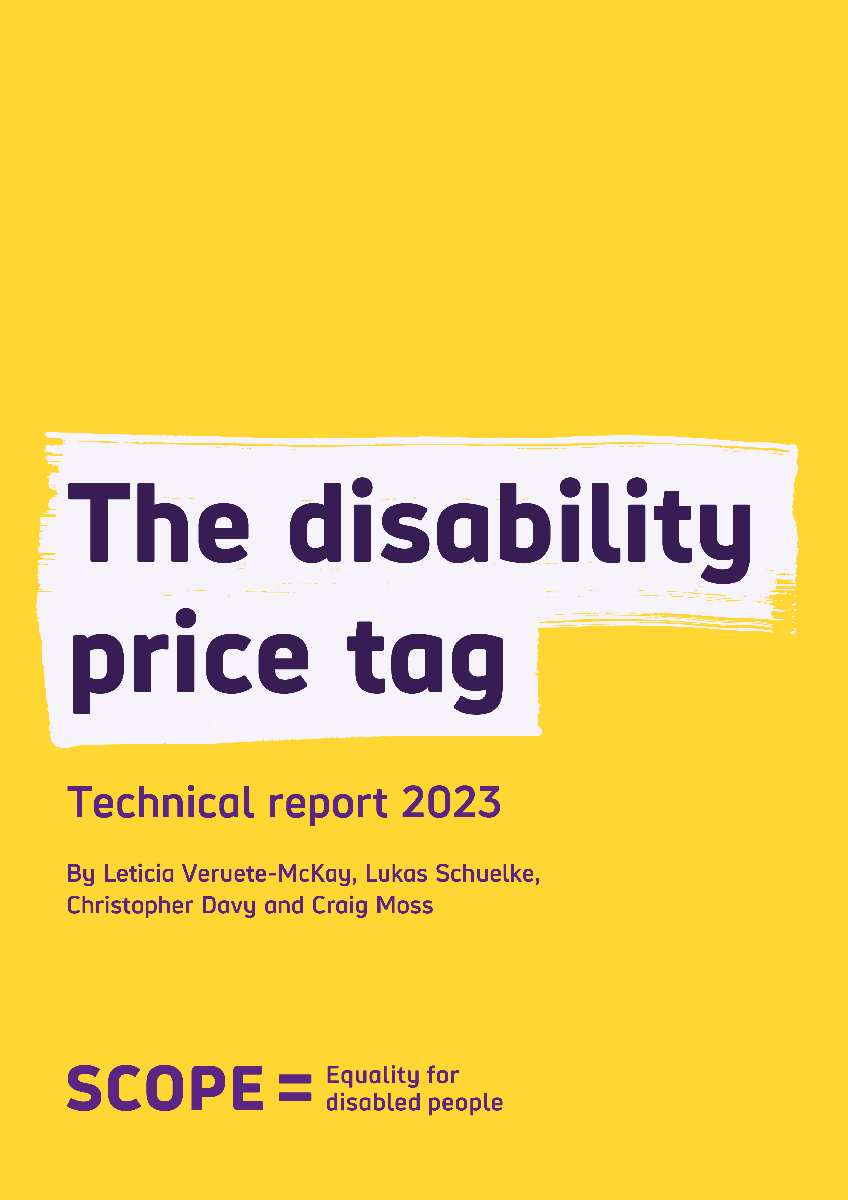
The Disability Price Tag
Technical Report 2023
Contents
Introduction 3
This report 5
Defining extra costs 6
Revising our methodology 7
Why we use median income 8
What is equivalised income? 8
A standard of living approach 9
Bringing this approach to life 10
Measuring Standard of Living 11
Measuring disability 13
Other socioeconomic and demographic factors 15
Calculating disabled households’ extra costs 16
Main Findings 18
Households with multiple conditions or impairments 20
Why is the extra cost of disability still so high? 21
Conclusion 23
Appendix 1 – Detailed methodology 24
Appendix 2 – Descriptive analysis of inputs from the Family Resources Survey 27
Appendix 3 – Differences in methodology 29

Introduction

In 2023 disabled people continue to face unfair extra costs. The higher cost of specialist equipment, higher usage of everyday essentials and energy, and an inadequate welfare system, are all making it harder for disabled households to meet the extra cost of disability.

Scope last published figures for the extra cost of disability in 2019. Since then, there has been a global pandemic, a cost of living crisis and soaring prices. More households have fallen into poverty and the number of disabled people out of work has increased.

These factors have had a huge impact on the lives of disabled people.

Since the last Disability Price Tag report there has been no action to tackle the extra cost of disability.

We define extra costs as the additional amount of money a disabled household would need to have the same standard of living of a non-disabled household.

Our analysis shows:

- On average, the extra cost of disability is equivalent to 63% of household income after housing costs.

For example, if a non-disabled household uses £1,000 per month to maintain their standard of living, an equivalent disabled household would need an additional £630 to have the same standard of living (totalling £1,630 per month). The extra expenditure may be due to higher transportation costs when going grocery shopping, using more energy on specialist equipment or on more heating to feel comfortable at home.

- Applying the 63% estimate to the median monthly equivalised household income of all households implies that, on average, disabled households (with at least one disabled adult or child) need an additional £975 a month to have the same standard of living as non-disabled households.
- If this figure is updated to account for inflation over the current period 2022/2023, these extra costs rise to £1,122 per month.
- The average extra costs rise to £1,248 per month where there are two disabled adults and at least two children in the household. And for households with one disabled adult, one non-disabled adult and at least one child, the average extra cost is £634.

These figures are accounting for disability benefit payments like Personal Independence Payments (PIP), which are designed to help address these costs.

The pressure on disabled households to meet these costs makes it harder to have a good standard of living. It makes it harder to build savings, and it makes it difficult to plan for the future.

Addressing the Disability Price Tag and reducing the extra cost of disability requires concerted action and commitment from government, regulators, and businesses. We need a welfare system which provides sufficient levels of support, and to make sure disabled households have fair and affordable access to essential services.

By working together to reduce and end the extra costs associated with disability, we can create a fairer, more equal society, where everyone can participate and reach their potential.

This report

Over the last decade we have helped build evidence on the extra cost of disability through ground-breaking research.

We know disabled people face an unfair financial penalty when going about their daily lives, whether it is requiring adaptions in the home or spending more on essential services.

In this technical report we update our estimates of extra costs using a ‘Standard of Living’ approach and the Family Resources Survey (FRS) dataset available from the Office of National Statistics. This matches our previous work.

We follow broadly the same methodology as in a recent published paper by Lukas Schuelke, Dr Luke Munford and Dr Marcello Morciano.

And we are grateful for their continual input and feedback on our work.

Defining extra costs

The Standard of Living approach assumes that disabled households are required to spend more on special equipment, home adaptations, medicines and therapies compared to non-disabled people with the same income level.

These additional costs may cause disabled people to divert their income to meet these costs, reducing their standard of living. If an individual is spending their money on simply making sure their basic needs are met, it leaves less to spend on other areas such as home maintenance, keeping their house warm, or a holiday.

We estimate the extra cost of disability by calculating extra costs for disabled households. These extra costs are defined as the additional monetary income (including disability benefit payments, other benefits and grants but excluding housing costs) required for disabled households to achieve the same standard of living as non-disabled households.

In other words, after controlling for socio-economic variables, the differences in standards of living between a disabled and a non-disabled household are due to the extra cost of disability.

To achieve the same standard of living as non-disabled households, disabled households need to be compensated with extra income to cover these costs.

Revising our methodology

For the Disability Price Tag 2023, we have revised our previous methodology to ensure our approach is:

- Simpler and allows for greater interpretation by policy makers and academics.

- Easy to replicate, allowing us to conduct our analysis more frequently and identify historical trends and projections.

Our current methodology is different in two main ways –

- We use a simpler measure of disability and include all ages.
Our previous work relied on constructing a disability index using questions about impairments or conditions. This enabled us to understand how the impairment or condition of a family member can affect the standard of living of the family. In this report we have introduced a simpler approach to disability, including everyone who identifies as disabled, even if they state their day-to-day activities are not limited.

- We calculate the extra cost of disability by household rather than by individual, using median equivalised household income.
Previously we calculated at a family benefit unit level and then equivalised to an individual working age adult level. It is common to measure income at the household level to determine how well off a household is and which position it occupies in the income distribution. The welfare of one individual in a household will depend not only upon their own income, but also on that of other household members.

The results in these changes to our methodology allow us to gain a better picture of the lives of disabled people. We now look at every household, not just working-age households. Our measure now focuses on the impact of the extra cost of disability on households, rather than on an individual, which we believe to be a better representation of implications of extra costs.

Why we use median income

The household income distribution across the UK has a high concentration of individuals with low levels of income, and a small proportion of households with very high levels of income. This implies that the mean will be higher than the median (the middle point of the distribution of ranked incomes from lowest to highest levels).

Because of this, we use the median equivalised household income to estimate the monetary value of disabled households’ extra costs across a variety of households. This approach is more representative of those households that are concentrated at the lower end of the income distribution, such as disabled households. It also takes into consideration the size and household composition, which are relevant when comparing the standard of living among households. Larger families with several children need a higher income to be able to afford the same standard of living as a couple without children, or a single adult with children.

What is equivalised income?

‘Equivalised’ means adjusting a household's income for size and composition to be able to compare the incomes of all households on the same basis. In other words, incomes are rescaled to account for the fact that households of different sizes and compositions have different needs.

Official income statistics use the 'Modified OECD' equivalence scale, in which an adult couple with no dependent children represents the benchmark with an equivalence scale of 1.

The equivalence scales for other types of households can be calculated by adding together the implied contributions of each household member. For instance, the head of household receives a conversion factor of 1, any further adult receive a factor of 0.5, with a factor of 0.3 for each child aged 0-13, and a factor of 0.5 for each child 14-18. In this report we used these.

A standard of living approach

Similar to our previous Disability Price Tag 2018 and 2019 calculations, we have used a standard of living approach – measuring the financial impact extra costs have on disabled households’ livelihoods.

This standard of living approach allows us to compare the financial situation across different households. It allows individuals to state if they can or cannot afford things, rather than rely on an external evaluation. This creates a real measure of the lived experiences of disabled and non-disabled individuals who will have varying and complex lives. This approach helps to remove a number of assumptions about the lives of disabled people. This allows us to utilise a more consist standard of living measure across households.

Figure 1 – Graphical representation of the Standard of Living approach

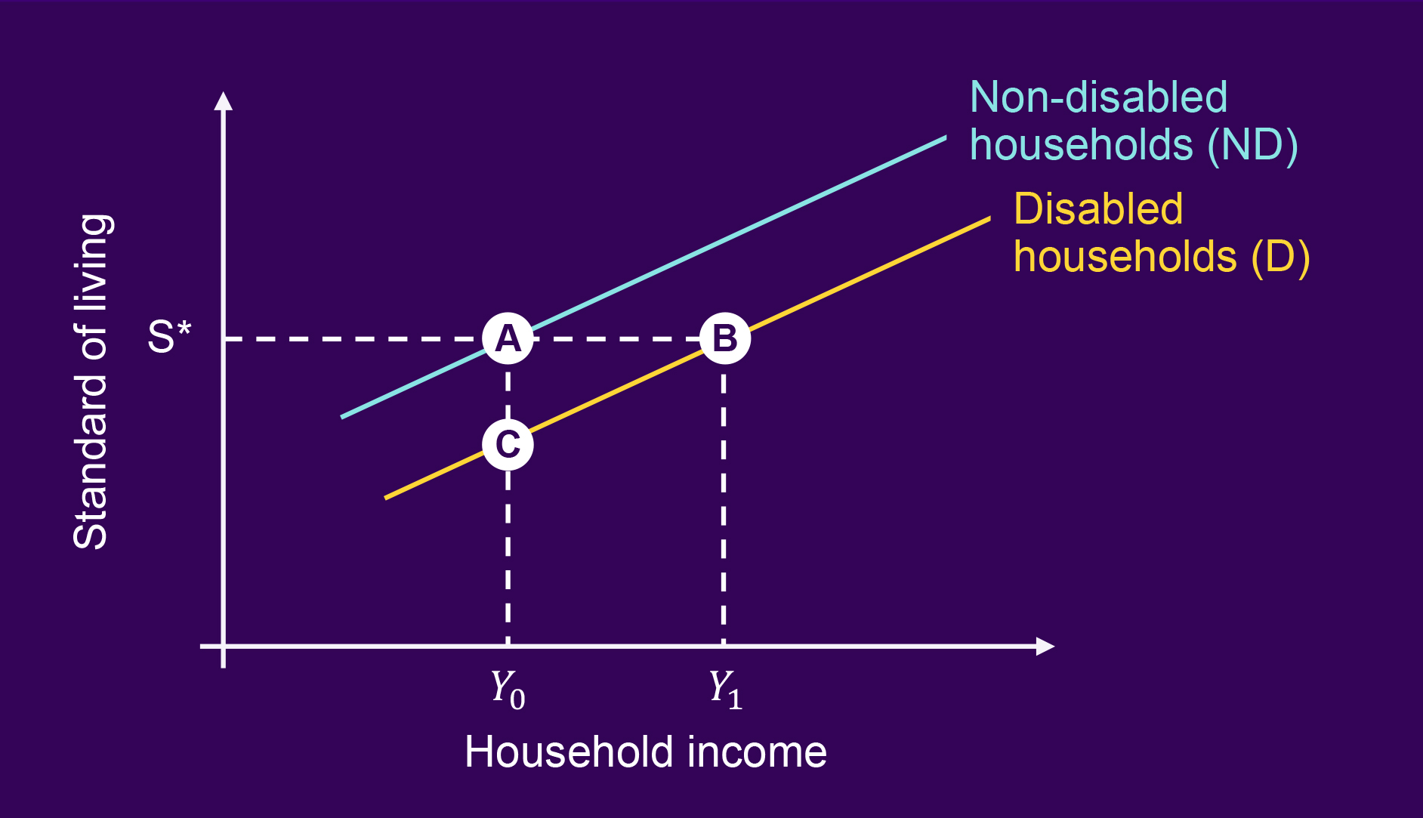

Figure 1 illustrates the relationship between standard of living and income across the population. We can distinguish two groups: non-disabled and disabled households. The blue line shows different levels of standard of living and income of non-disabled households. Similarly, the yellow line depicts different levels of standard of living and the corresponding income of disabled households.

Notably, disabled households experience a lower standard of living than non-disabled households at all levels of income. This is because they face an additional cost of disability which causes them to divert their income. They have less income to afford everyday goods and services compared to non-disabled households.

To address this, disabled households need to be compensated with additional income to achieve the same standard of living level S* as the non-disabled counterparts (increasing from point C to reach point B, in Figure 1 above).

Bringing this approach to life

Thinking of two families with broadly similar incomes can help us to understand better how the standard of living approach works in real life.

We identified a family with two disabled adults and 3 dependent children, of which two are disabled, from the FRS dataset. Their weekly equivalised income including benefits is £312 and they live in rented accommodation in Northern England. When asked about how many items the family can afford out of a list of 7, this family stated that could afford 4 of them.

We can compare them to another family in the dataset with no disabled people, but still with 2 adults and 3 children and a weekly equivalised income of £312 who live in rented accommodation in a similar area. They can afford all the 7 items.

It is the family with non-disabled members who can afford more items and has a higher standard of living, compared to the family with disabled members. To allow the disabled family to achieve the same standard of living as the non-disabled family, they would need to be compensated with additional income to make up for the extra costs associated with disability.

Measuring Standard of Living

Our analysis is based on the Family Resource Survey (FRS), a nationally representative dataset used to provide official statistics on social welfare issues. We have used the 2019/2020 dataset, which is the latest dataset currently available not effected by non-usual household behaviour and financial activity as a result of the coronavirus pandemic.

The FRS collects information on material deprivation indicators and is measured through a set of questions asking whether a family can afford an item and has it, would like to have it but cannot afford it, or can afford it but does not want it.

Our analysis has been computed at a family benefit unit level as this is the format provided for the material deprivation indicators that we use for measuring the standard of living.

Over 19,000 households were interviewed for the FRS between April 2019 to March 2020.

Material deprivation indicators are collected on a range of items and activities that a household can afford (e.g., being able to replace worn out furniture, being able to go on holidays for at least one week a year, make a saving of £10 a month or more, etc). These indicators allow us to gauge the household’s reported inability to afford important goods and services. Since 2004/05, the FRS included 11 questions on material deprivation that have been derived from the concept of consensual necessities.

Material deprivation is an appropriate measure when comparing standards of living between households that face different costs of living. The Department for Work and Pensions uses information on material deprivation to understand the standard of living for families. Each item that a household can afford is counted. Households stating that they can afford more items get higher counts, indicating that are less materially deprived in comparison to the more deprived households, who get lower counts.

Using the 7 adult questions of the material deprivation from the FRS, in this report we constructed a standard of living composite index. This composite index takes the value 1 for households who scored either 0, or 1 count out of the 7 items. Counts of two and three correspond to a value of 2. If a household had 4 counts, the composite index will be set to 3 and so on. The highest value of 6 in the composite index equals to seven positive responses and is associated with a high standard of living, because the family has the resources to afford all 7 items. However, a family with less income may not be able to afford the same number of items and thus scores lower on the standard of living scale.

A higher proportion of disabled households have low levels of standard of living compared to non-disabled households (see Figure 2 below)

Figure 2 – Standard of living index by disability

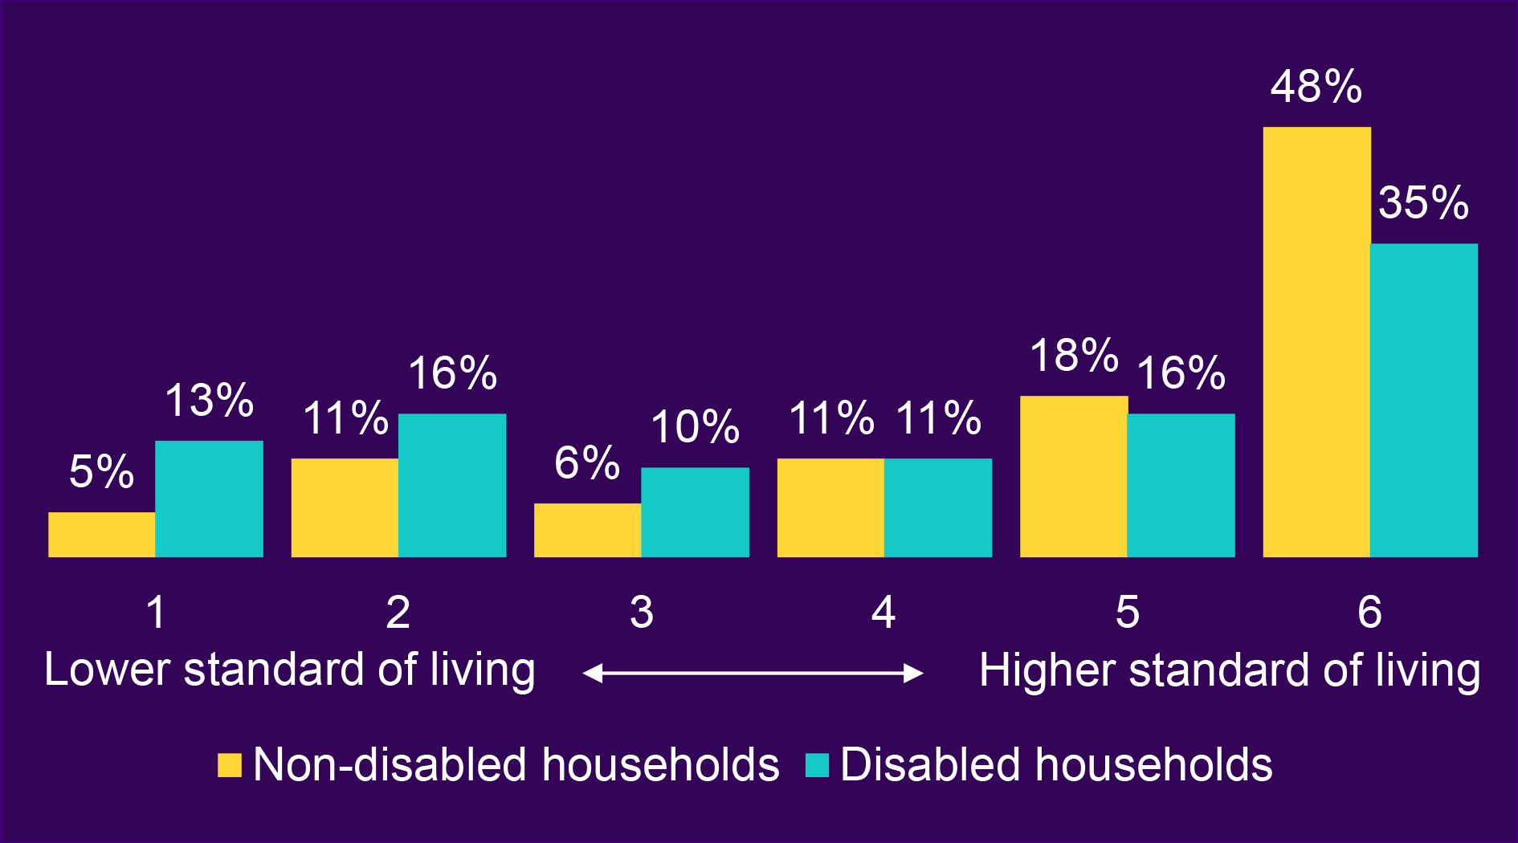

Source: Scope calculations using Family Resources Survey 2019/20 based on weighted sample, considering at least one disabled member in the household (wider definition)

Measuring disability

The Family Resource Survey (FRS) gathers information on two definitions consistent with the Equality Act 2010. In the UK Government ‘core’ definition, a person is considered to ‘have a disability’ if they have:

- a physical or mental impairment, and
- the impairment has a substantial and long-term adverse effect on person’s ability to carry out normal day-to-day activities.

The ‘wider’ definition includes individuals that are disabled and have a condition or impairment which does not affect their day-to-day activity.

Other studies, including the Disability Price Tag Report 2018, have considered measuring the types and number of impairments or conditions. However, the questions in the FRS change over survey years making it difficult to maintain consistency.

In this report we used the wider disability definition to identify households with at least one disabled member (see Figure 3 below), creating two different binary variables:

- One that identifies at least one disabled adult or at least one disabled child in the household.

- Another that identifies the number of disabled adults within the household.

We also created a binary variable using the core definition of disability.

Figure 3 – Disability prevalence

Disability | No of at least one disabled member in the household | No of non-disabled members in the household | Total
Wider definition | 8,667 (47%) | 9,719 (53%) | 18,386
Core definition | 6,141 (34%) | 12,245 (66%) | 18,386
Source: Scope calculations based on the Family Resources Survey 2019/20, unweighted sample size.

Other socioeconomic and demographic factors

Household income is measured using the total available household resources before taxes. We have included all disability benefit payments in this model as income, such as Personal Independence Payments (PIP), in addition to income from investments, grants or pensions.

The reported extra costs figures are in addition to all disability and other social security benefit payments received. We do not remove direct taxes, but in line with other studies, we subtract housing costs from the total gross household income.

Our model also accounts for housing tenure, employment status, housing type (rented or owned for example), location, age of the head of household, the size and composition of the household, as well as number of dependent children.

Calculating disabled households’ extra costs

We have calculated disabled households’ extra costs as the additional income required to achieve the same standard of living as non-disabled households using an ordered logit model. This is a more simplified model compared to previous Scope Disability Price Tag reports. This means we moved away from the Structural Equation Model (SEM), of two equations, in the Disability Price Tag Report 2019.

In this report we considered all households in the FRS (over 19,000 households) including:

- Single individuals with and without children
- Couples or single parents with and without children
- Adults over 65 years old
- Individuals whether working (full or part time)
- Individuals unemployed or inactive

Our results for 2019/2020 are displayed in Figure 4, along with an adjusted baseline for 2016/2017.

On average, disabled households’ extra costs were equivalent to 63% of their household income, after housing costs. This means, for example, if a non-disabled household has £1,000 per month to maintain their standard of living, an equivalent disabled household will need an additional £630 to have the same standard of living (totalling £1,630 per month). The extra expenditure may be due to higher transportation costs when going grocery shopping, using more energy on specialist equipment or on more heating to feel comfortable at home.

Looking back to 2016/17, it is estimated that disabled households’ extra costs were equivalent to 48% of income. The extra cost of disability has increased.

If we use the median equivalised household income net of housing costs in 2019/20 (£357 weekly income), disabled households need, on average, £975 of additional income in a month to have the same standard of living as non-disabled households.

Figure 4 – Estimated disabled households’ extra costs (at least one disabled adult or at least one disabled child in the household), baseline

Disability | 2016/17 | 2019/20
Number of observations | 18,232 | 18,031
% | 48% | 63%
£ monthly | 645 | 975
£ monthly (prices 2022/23) | 742 | 1,122

Source: Scope calculations based on the FRS various fiscal years, considering at least one disabled member in the household.

Main Findings

All Households, (where there is at least one disabled adult or disabled child in the household)

On average, disabled households need an additional £975 a month in income to achieve the same standard of living as non-disabled households. This is after benefit payments are taken into account.

All Households (where there at least one disabled adult, but no disabled children in the household)

On average, disabled households would need an additional £919 a month in income to achieve the same standard of living as non-disabled households. Similarly, this is after benefit payments are taken into account.

Households with children

The headline figure can mask households facing high extra costs, in particular those with more disabled members, or a larger number of dependent children. For households with:

- two disabled adults or more and at least two children, the average extra costs rise to £1,248 per month

- one disabled adult, one non-disabled adult and at least one child, the average extra costs are £634 per month

- one single disabled adult with at least one child, they face average extra costs of £515 per month

- at least one disabled adult and at least one disabled child, they face average extra costs of £879 per month.

Larger households affected by poverty (with at least two adults and two or more children)

Disability, and being a disabled person, are linked with societal exclusion and additional barriers to employment in the UK, leading to financial hardship or poverty. This is partly because disabled individuals have a much lower rate of employment and salary compared to non-disabled workers. Equally, disabled people are 3 times more likely to be economically inactive (citing long term illness or disabilities) compared to their non-disabled peers.

Poverty rates are much higher amongst households where at least one person is disabled (32%) compared to those in households where no one is disabled in 2019/20 (20%). Although poverty among disabled households has come down since 2020/21, it remains at the same level as 2005/06.

To determine those affected by poverty, it is common to use a relative measure that tells us the number of people within a household in relative low income. So to define a poverty line, we categorised individuals living in households with income below a certain percentage of the median equivalised household income as ‘in poverty’. We used 60% and the median of the equivalised household income of £357 weekly for 2019/20. This means that the poverty line is a weekly income of £214.

We estimate that the extra costs for disabled households below the poverty line to be 60% of household income, in comparison to those above the poverty line at 50% of household income. This shows a higher financial burden among those in a financial precarious position, such as those on low income levels compared to those with higher income levels.

Households with multiple conditions or impairments

Previous studies have found that individuals experiencing more than one support needs for their conditions or impairments have higher extra costs.

We found that over 40% of households have an adult who has 1 impairment, and 16% of households have adults with 2 impairments (see figure 5).

We estimate that extra costs for households reporting 1 or 2 impairments or conditions is £672, and for households with 3 or 4 impairments or conditions the extra costs are £738 per month.

Figure 5 – Proportion of adults with impairments or conditions within households

Number of impairments or conditions | 2019/20
With no impairments or conditions | 19.4%
One impairment or condition | 44.4%
Two impairments or conditions | 15.8%
Three impairments or conditions | 8.6%
Four impairments or conditions | 5.4%
Five impairments or conditions | 2.7%
More than six impairments or conditions | 3.7%

Source: Scope own calculations based on the FRS various fiscal years, based on weighted sample.
Notes: We excluded missing observations coded as -1 in the FRS dataset

Why is the extra cost of disability still so high?

There are three main reasons why the extra cost of disability remains high.

- A stall in income and benefit levels
The extra cost of disability is a relative measure. Changes in income and the standard of living of both disabled and non-disabled households may cause an increase in the estimation of extra costs.

Between 2016/17 and 2019/20, the poorest fifth (20%) of households saw their income fall by 11% in real terms (once adjusted for inflation). Many disabled households now have some of the lowest income levels in the country, with a third of disabled people (33%) in the lowest household income decile.

On top of the stagnation of lower income growth, vital out-of-work benefits were frozen, such as Universal Credit and Employment Support Allowance.

- Gap in poverty rates of disabled households versus non-disabled households widened in 2019/20

In the decade to 2019/2020, the poverty rate for individuals who live in households where someone is disabled has been broadly 32%, 12 percentage points higher than those who live in households where no one is disabled in 2019/20. Of all households in poverty, just under half contain someone who is disabled, compared to 3 in 10 families not in poverty.

Households in poverty are more likely to have to pay more for essential services – like energy – due to premiums associated with a lack of direct debit payment methods and Pre-Payment Meters.

Many disabled households face extra costs they simply cannot afford, pushing these households deeper into poverty.

- Impact of inflation on household budgets and costs of living

High inflation erodes what households can afford. Between 2016/2017 and 2019/2020 inflation increased by 7%. And in 2022, soaring energy prices resulted in inflation of double figures further causing increases in food prices and other essentials, with disabled households among some of the worst affected.

Disabled households devote higher proportions of their household budget on energy bills and shopping for food and drink. The gap between disabled and non-disabled households’ ability to afford basic items has widened. Disabled people are almost three times as likely to live in material deprivation than the rest of the population (34% vs 13%).

Government Cost of Living payments in 2022 and 2023 were designed to help families meet these rising prices. However, 80% of disabled people said these payments were not enough to meet the increased costs they faced.

Conclusion

Since we began campaigning on reducing the extra costs faced by disabled households, we have seen limited action to tackle the extra cost of disability.

Unfortunately, as this report demonstrates, disabled households still face a significant financial penalty – a penalty which has increased from 48% to 63% of their household income.

This means, disabled households need a higher proportion of additional income in 2019/20 to achieve the same standard of living of non-disabled households than they did in 2016/17.

We will now monitor and routinely report on the extra cost of disability.
As disabled households’ extra costs have increased since 2016/17, it is vital that the Government targets support for extra costs to those who most need it. By ending the extra costs associated with disability, we can create a fairer, more equal society.

Tackling the extra cost of disability must be seen as a political priority, so that every disabled person can participate in society and reach their potential.

Appendix 1 – Detailed methodology

This section describes the methodological approach and the Econometric model used to estimate the disabled households’ extra costs.

Standard of Living approach

The standard of living approach allows us to compare the financial situation across differing households. That is, individuals state if they can or cannot afford items, creating a real measure of the lived experience of disabled and non-disabled people who have varying and complex lives. This approach removes a significant number of assumptions and permits to focus on the real standard of living, delivering a valued insight into the lives of disabled people.

The standard of living approach can also be explained graphically to understand the relationship between the standard of living (S) and income (Y), for disabled households (D) and for a comparable non-disabled household (ND).

The illustration below displays a positive relationship between standard of living and income, indicating that households with higher incomes will achieve a higher standard of living. Conversely, those with lower incomes will face a lower standard of living.

Figure 6 – Graphical representation of the Standard of Living approach

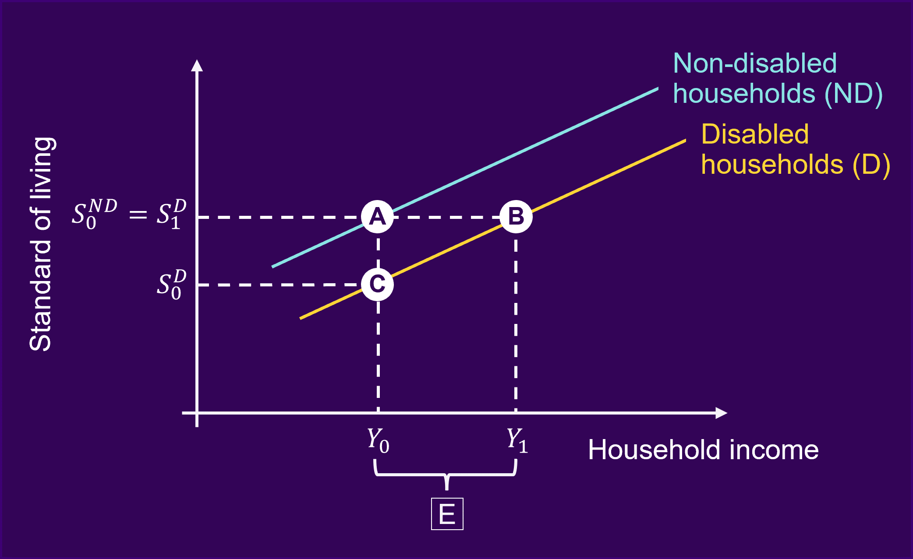

As shown graphically, at the same income level (Y₀), non-disabled households can experience a standard of living at point A, (S₀ND) compared to the lower level experienced by disabled household (S₀^{D}) at point C. This is because disabled households face additional barriers and costs which increases their costs that non-disabled households do not experience.

Therefore, to achieve the same standard of living of the non-disabled counterpart, disabled households (S₁^{D}) would require an additional income, E, from Y₀ to get the income level (Y₁), reaching point B in the above image, where Y₁ = Y₀ + E.

Econometric model

We estimated an ordered logit model as visually described in Figure 7 below. The dependent variable is the standard of living index (with ordered scores of affordability of items from 1 to 6 levels), indicating a low to high standard of living. The model used household income, but size and composition of the households was taken into account among other factors outlined below. Note that the relevant estimated coefficients in this model are α and β, related to household income and identifying at least one disabled member within the household. The vector γ consists of coefficients related to the other factors, which account for any differences among households.

Figure 7 – Model for standard of living on household income, disability and other factors

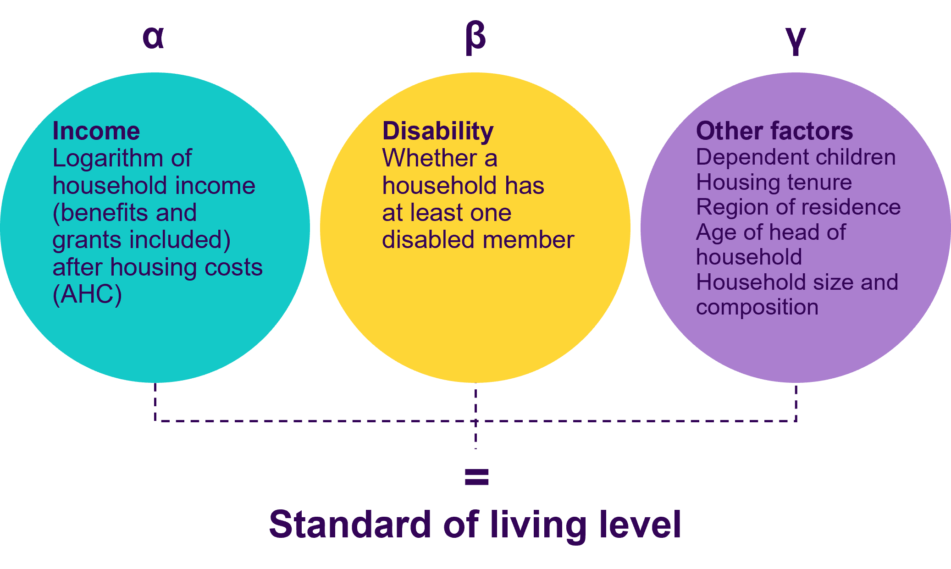

At point B in Figure 6, for the two groups to have the same standard of living, it needs to satisfy this condition:

α (Y₀ + E) + β (D = 1) + γ X = α Y₀ + β (D = 0) + γ X

where:

D = 1 means that households have at least one disabled member and

D = 0 indicates that households do not have any disabled members.

In the equation above, when solving for E it can be shown that E is equal to -β/α. This ratio of two coefficients of the model represents the extra costs of disabled households expressed as percentage of household income, that is, -β divided by α, and then multiplied by 100. The monthly monetary value (£) can be derived by multiplying -β/α by the median equivalised household income level.

Appendix 2 – Descriptive analysis of inputs from the Family Resources Survey

A recent Institute of Fiscal Studies (IFS) study has identified a strong association between disability and material deprivation. In 2019/2020 among those disabled benefit claimants, more than half (53%) were in the most materially-deprived fifth of the population.

We considered 7 questions on material deprivation, reported below. Consistent with the IFS study, disabled households are at least 1.5 times as likely to experience material deprivation compared to non-disabled households, with some exceptions.

Although a higher proportion of disabled households cannot afford certain items/services compared to non-disabled ones, this proportion has reduced in 2019/2020 for both groups.

Figure 8 – Deprivation indicators by disability

Deprivation indicators | 2016/17 |  | 2019/20
Would you (and your family/and your partner) like but cannot afford to… | Disabled household  (at least one disabled member) | Non-disabled household | Disabled household  (at least one disabled member) | Non-disabled household
Keep your home in a decent state of decoration | 23 | 16 | 21 | 13
Can afford holidays away from home one week a year and staying with relatives at their home | 44 | 27 | 40 | 24
Get households content insurance? | 30 | 28 | 30 | 27
Can make a £10 or more saving | 43 | 26 | 37 | 20
Replace any worn out furniture? | 41 | 31 | 39 | 26
Replace or repair broken electrical good such as refrigerator or a washing machine goods | 30 | 25 | 29 | 21
Can afford to have money to spend each week on yourself, not on your family | 27 | 15 | 23 | 11

Source: Scope calculations based on the FRS various years. Figures are derived using the wider disability definition of at least one disabled member, weighted sample.

Appendix 3 – Differences in methodology

Our new methodology differs to previous Scope Disability Price Tag work.

The table below sets out the differences in approach.

 | Disability Price Tag Report 2019 | Disability Price Tag  2023
Unit of measure in the estimation of extra costs | Benefit unit | Unique households within the benefit unit
Social material deprivation, adult questions | Used 9 questions | Used 7 questions, these are available in 2016/2017 and for every year thereafter, required to construct a baseline in the new method of estimation.
Standard of Living indicator index (for adults and children) | Latent method | Constructed an index based on the number of counts for those that can afford 7 items/activities from adult material deprivation questions. Much quicker to estimate than using a latent method.
Method of estimation | Structural equation model (SEM), with two simultaneous equations on standard of living and disability | Ordered logistic regression of one equation, much easier to estimate, less computationally intensive in comparison to the SEM.
Disability | Using latent method based on number of impairments faced by adults and children to estimate an adult and children disability indices | Used the wider definition to construct a binary variable that counts how many disabled members are within the household, less computationally intensive in comparison to the latent method and constructing the disability indices for adults and children.
Household income | Net income (after housing costs) at benefit unit | Gross household income (after housing costs), this variable is already available in the FRS, no need to manipulate the variable, so less errors, only stripping housing costs.
Relationship between standard of living and income | Non-linear | Linear, much easier to estimate and less computationally intensive compared to running a nonlinear- equations.
Sample | Working age population (16-64 years) and children | Adults from 16 years and children, capturing adults above 65 years, who are more prone to experience a health conditions or impairments.

Notes: Disability Price Tag Report 2018 follows the Standard of Living approach but did not include children’s standard of living and disability indices in the analysis.

Consumer Price Index (CPI) inflation rate between 2019/20 and 2022/23 was 15.1%, this was used to uprate the 2019/20 figure to express at prices of 2022/23.
Schuelke, L., Munford, L. and Morciano, M. (2022) Estimating the additional costs of living with a disability in the United Kingdom between 2013 and 2016. European Journal of Health Economics 23, pp.313–327. https://doi.org/10.1007/s10198-021-01366-1
Calculated as adult equivalent.
About the tool | Institute for Fiscal Studies https://ifs.org.uk/about-tool
OECD note Equivalence Scales https://www.oecd.org/els/soc/OECD-Note-EquivalenceScales.pdf
Households that have at least one disabled adult and have at least one disabled child were considered. The core definition of disability was used to identify disabled children within the household to understand the impact on extra costs faced by adult members in households who care for their disabled children, and whose child’s ‘daily activities are limited by the child’s condition or impairment’ as per UK Government definition of disability.
Scope calculations based on the microdata of Quarterly Labour Force Survey various quarters.
Joseph Rowntree Foundation, 'UK Poverty Report Statistics’ (2023) https://www.jrf.org.uk/data?f%5B0%5D=field_taxonomy_poverty_indicator%3A922
Office of National Statistics analysis of Household Finances Survey 2010/11 to 2019/2020 https://www.ons.gov.uk/peoplepopulationandcommunity/personalandhouseholdfinances/incomeandwealth/bulletins/householddisposableincomeandinequality/financialyear2020
Resolution Foundation (2023) Costly differences: Living standards for working-age people with disabilities https://www.resolutionfoundation.org/app/uploads/2023/01/Costly-differences.pdf
House of Commons Library (2022) Benefits uprating 2023/24 https://researchbriefings.files.parliament.uk/documents/CBP-9680/CBP-9680.pdf
Joseph Rowntree Foundation Poverty Report 2023 https://www.jrf.org.uk/data/poverty-rates-disabled-people
Davies, S. and Collings, D. (2021) The inequality of poverty: exploring the link between the poverty premium and protected characteristics, University of Bristol https://www.bristol.ac.uk/geography/research/pfrc/themes/financial-exclusion-poverty/inequality-of-poverty/
Consumer Price Index (CPI) inflation rate between 2016/17 and 2019/20 was 7%
Resolution Foundation (2023) Costly differences: Living standards for working-age people with disabilities https://www.resolutionfoundation.org/app/uploads/2023/01/Costly-differences.pdf
Scope (2022) Cost of Living: the impact of disabled people https://www.scope.org.uk/campaigns/research-policy/cost-of-living-report/
The monthly income is calculated by multiplying weekly income figure by 52 divided by 12.

