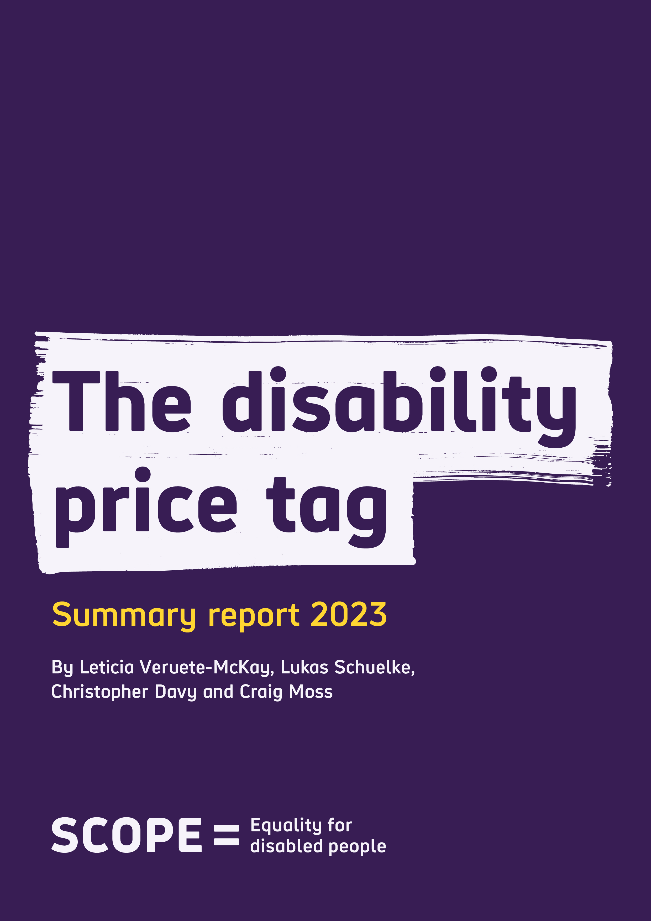

The Disability Price Tag Summary Report 2023
Contents
Disability Price Tag 2023: The extra cost of disability 3
What are extra costs? 5
Why is the extra cost of disability still so high? 6
What needs to change 8
Calculating the Disability Price Tag – our new methodology 9

Disability Price Tag 2023:
The extra cost of disability

In 2023 disabled people continue to face unfair extra costs. The higher cost of specialist equipment, higher usage of everyday essentials and energy, and an inadequate welfare system, are all making it harder for disabled households to meet the extra cost of disability.

Scope last published figures for the extra cost of disability in 2019. Since then, there has been a global pandemic, a cost of living crisis and soaring prices. More households have fallen into poverty and the number of disabled people out of work has increased.

These factors have had a huge impact on the lives of disabled people.

Since the last Disability Price Tag report there has been no action to tackle the extra cost of disability.

We define extra costs as the additional amount of money a disabled household would need to have the same standard of living of a non-disabled household.

Our analysis shows:

- On average, disabled households (with at least one disabled adult or child) need an additional £975 a month to have the same standard of living as non-disabled households.

- If this figure is updated to account for inflation over the current period 2022/2023, these extra costs rise to £1,122 per month.

- On average, the extra cost of disability is equivalent to 63% of household income after housing costs.
- The average extra costs rise to £1,248 per month where there are two disabled adults and at least two children in the household. And for households with one disabled adult, one non-disabled adult and at least one child, the average extra cost is £634.

These figures are accounting for disability benefit payments like Personal Independence Payments (PIP), which are designed to help address these costs.

The pressure on disabled households to meet these costs makes it harder to have a good standard of living. It makes it harder to build savings, and it makes it difficult to plan for the future.

Addressing the Disability Price Tag and reducing the extra cost of disability requires concerted action and commitment from government, regulators and businesses. We need a welfare system which provides sufficient levels of support, and to make sure disabled households have fair and affordable access to essential services.

By working together to reduce and end the extra costs associated with disability, we can create a fairer, more equal society, where everyone can participate and reach their potential.

What are extra costs?
We define extra costs as the additional amount of money a disabled household would need to have the same standard of living as a non-disabled household.

Disabled households have to divert their income to pay for specialist products and services, as well as pay more for the basics. These include:

- Spending on specialist disability-related products and services that are essential and often costly; and include things like vital specialist equipment, mobility aids, car or home adaptations, medicines and therapies which are all expensive.
- Needing to spend more everyday things – booking a holiday may lead to extra costs due to a lack of availability of accessible rooms; limited mobility may mean needing to purchase more expensive ready meals or rely on the delivery of household goods more.

- Higher usage of essentials – many disabled households have to use more energy or extra accessible transport options.

Extra costs do not just relate to money that has actually been spent, but also to purchases and services that disabled households have to go without because their available income has been used up on the basics.

In other words, not every disabled household is able to meet the extra cost of disability.

Disability benefit payments, like Personal Independence Payments (PIP), are designed to help offset these costs. However, even after taking PIP into account, the average disabled household (including at least one disabled adult or child) faces extra costs of £975 per month.

Why is the extra cost of disability still so high?

There are three main reasons why the extra cost of disability remains high.

- A stall in income and benefit levels
The extra cost of disability is a relative measure. Changes in income and the standard of living of both disabled and non-disabled households may cause an increase in the estimation of extra costs.

Between 2016/17 and 2019/20, the poorest (20%) of households saw their income fall by 11% in real terms (once adjusted for inflation). Many disabled households now have some of the lowest income levels in the country, with 33% of disabled people in the lowest household income group.

On top of the stagnation of lower income growth, vital out-of-work benefits were frozen, such as Universal Credit and Employment Support Allowance.

- Gap in poverty rates of disabled households versus non-disabled households widened in 2019/2020

In the decade to 2019/2020, the poverty rate for individuals who live in households where someone is disabled has been broadly 32%, 12 percentage points higher than those who live in households where no one is disabled in 2019/20. Of all households in poverty, just under half contain someone who is disabled, compared to 3 in 10 families not in poverty.

Households in poverty are more likely to have to pay more for essential services – like energy –due to premiums associated with a lack of direct debit payment methods and Pre-Payment Meters.

Many disabled households face extra costs they simply cannot afford, pushing these households deeper into poverty.

- Impact of inflation on household budgets and costs of living

High inflation erodes what households can afford. Between 2016/17 and 2019/2020 inflation increased by 7%. And in 2022, soaring energy prices resulted in inflation of double figures further causing increases in food prices and other essentials, with disabled households among some of the worst affected.

Disabled households devote higher proportions of their household budget on energy bills and shopping for food and drink. The gap between disabled and non-disabled households’ ability to afford basic items has widened. Disabled people are almost three times as likely to live in material deprivation than the rest of the population (34% vs 13%).

Government Cost of Living payments in 2022 and 2023 were designed to help families meet these rising prices. However, 80% of disabled people said these payments were not enough to meet the increased costs they faced.

What needs to change

The current cost of living crisis has only increased the financial challenges faced by disabled households when it comes to extra costs.

Action from government, companies and regulators has been promised but has not been delivered.

Tackling the extra cost of disability must be seen as a political priority, so that every disabled person can participate in society and reach their potential.

Addressing the extra cost of disability requires action on multiple fronts:

- A commitment from government to prioritise tackling the extra cost of disability. This must first focus on designing a welfare system that lifts disabled households out of poverty, as well as accurately capturing the full range and type of extra costs faced by disabled people.

- The creation of an Energy Social Tariff for disabled households. A discounted rate for disabled people who need to use more energy, to target financial support to those who need it most.

- Action from regulators, such as Ofgem and Ofcom, to make sure that disabled people don’t overpay for everyday essential services.

Scope, with research partners, will be looking at the root causes and drivers of the extra cost of disability, exploring the relationship these costs have on disabled household finances, decision-making and standards of living.

Calculating the Disability Price Tag – our new methodology
In calculating the latest Disability Price Tag figure, we have used a Standard of Living approach consistent with our previous research and academic work on extra costs, poverty and poverty premiums.,

The extra cost of disability is measured by comparing the difference in the standard of living between disabled and non-disabled households. We measured the standard of living based on a household’s ability to afford key items or conduct essential tasks. This includes purchasing household contents insurance, or repairing and replacing broken electrical goods, as well as having small amounts to spend each week and enough to save a little.

Our analysis accounts for factors such as location, employment situation and income levels. This means we are confident that difference in standard of living, and the amount of money needed to achieve the same standard of living is because of disability-related costs.

We have also used equivalised household income, to compare a variety of household compositions in different settings, from single individuals to families made up of both adults and children.

Scope’s previous Disability Price Tag research found an average extra cost of £583 (per person) per month. However, our 2023 figure is non-comparable as we have developed and revised our modelling. If we recalculate our previous figure using our new approach, our new baseline average extra cost was £645. Suggesting a rise of £330 over three years to our current figure of £975 for 2019/2020.

In this revision of the Disability Price Tag methodology, we have implemented three important changes to our estimate of extra cost of disability:

- Extra costs are now presented by household (per adult-equivalent) rather than by individuals, to allow comparison across all household compositions.

- Average extra costs are now calculated using the median income, to more accurately represent the distribution of disabled household incomes.

- Inclusion of disabled people of all ages, as well as expanding our definition of disability to cover those individuals identifying as disabled even if they state that their day-to-day activities are not limited.

All three of these changes made our previous estimation slightly higher. We believe the changes to our methodology provide a more accurate estimation of the extra cost of disability.

Consumer Price Index (CPI) inflation rate between 2019/20 and 2022/23 was 15.1%, this was used to uprate the 2019/20 figure to express at prices of 2022/23.
Office of National Statistics analysis of Household Finances Survey 2010/11 to 2019/2020 https://www.ons.gov.uk/peoplepopulationandcommunity/personalandhouseholdfinances/incomeandwealth/bulletins/householddisposableincomeandinequality/financialyear2020
Resolution Foundation (2023) Costly differences: Living standards for working-age people with disabilities https://www.resolutionfoundation.org/app/uploads/2023/01/Costly-differences.pdf
House of Commons Library (2022) Benefits uprating 2023/24 https://researchbriefings.files.parliament.uk/documents/CBP-9680/CBP-9680.pdf
Joseph Rowntree Foundation Poverty Report 2023 https://www.jrf.org.uk/data/poverty-rates-disabled-people
Davies, S. and Collings, D. (2021) The inequality of poverty: exploring the link between the poverty premium and protected characteristics, University of Bristol https://www.bristol.ac.uk/geography/research/pfrc/themes/financial-exclusion-poverty/inequality-of-poverty/
Consumer Price Index (CPI) inflation rate between 2016/17 and 2019/20 was 7%
Resolution Foundation (2023) Costly differences: Living standards for working-age people with disabilities https://www.resolutionfoundation.org/app/uploads/2023/01/Costly-differences.pdf
Scope (2022) Cost of Living: the impact of disabled people https://www.scope.org.uk/campaigns/research-policy/cost-of-living-report/
Scope (2019) Disability Price Tag Report https://www.scope.org.uk/campaigns/extra-costs/disability-price-tag/
Schuelke, L., Munford, L. and Morciano, M. (2022) Estimating the additional costs of living with a disability in the United Kingdom between 2013 and 2016. European Journal of Health Economics 23, pp.313–327.https://doi.org/10.1007/s10198-021-01366-1

